**MCInc vs MCIc – X axis (transverse plane)**



**Approach 1 - 2019_04_24_12_23**

**Network:**

Transfer learning from AlexNet changing last 3 layers.

|  |  |
| --- | --- |
| **Training parameters:**   * folds=3; * miniBatchSize = 20; * learningRate = 1e-4; * maxEpochs=40; * optimizer='sgdm'; * "L2Regularization", 0.0001 * "Momentum", 0.889 * 'Shuffle','every-epoch' | **Dataset:**   * nSlices=6; * gap=2; |

**Results:**

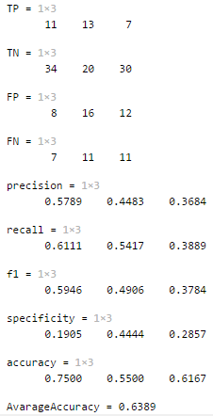

**Approach 2 - 2019_04_24_12_41**

**Network:**

Transfer learning from AlexNet changing last 3 layers.

|  |  |
| --- | --- |
| **Training parameters:**   * folds=3; * miniBatchSize = 30; * learningRate = 1e-4; * maxEpochs=50; * optimizer='sgdm'; * "L2Regularization", 0.0001 * "Momentum", 0.889 * 'Shuffle','every-epoch' | **Dataset:**   * nSlices=6; * gap=2; |

**Results:**

